**Entropy**

Entropy is a statistical measure of randomness that can be used to characterize the texture of the input image.

Entropy is defined as -sum(p.*log2(p)), where p contains the normalized histogram counts returned from [imhist](https://in.mathworks.com/help/images/ref/imhist.html).

The entropy of an image is defined as follows:

Entropy=[entropy](https://i.stack.imgur.com/EkmZI.gif)

## References

[1] Gonzalez, R. C., R. E. Woods, and S. L. Eddins. Digital Image Processing Using MATLAB. New Jersey, Prentice Hall, 2003, Chapter 11.

**PSNR:**

The psnr function implements the following equation to calculate the Peak Signal-to-Noise Ratio (PSNR):

*PSNR*=10log10(*peakval*2/*MSE*)



where peakval is either specified by the user or taken from the range of the image datatype (e.g. for uint8 image it is 255). MSE is the mean square error,

**SSIM:**

The Structural Similarity (SSIM) Index quality assessment index is based on the computation of three terms, namely the luminance term, the contrast term and the structural term. The overall index is a multiplicative combination of the three terms.

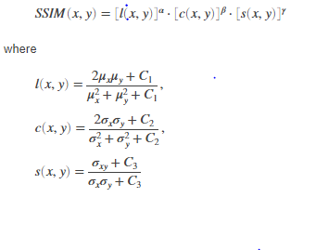

where μx, μy, σx,σy, and σxy are the local means, standard deviations, and cross-covariance for images x, y. If α = β = γ = 1 (the default for [Exponents](https://in.mathworks.com/help/images/ref/ssim.html#bt5rkbx-1-Exponents)), and C3 = C2/2 (default selection of C3) the index simplifies to:

*SSIM*(*x*,*y*)=(2*μxμy*+*C*1)(2*σxy*+*C*2)(*μ*2*x*+*μ*2*y*+*C*1)(*σ*2*x*+*σ*2*y*+*C*2)

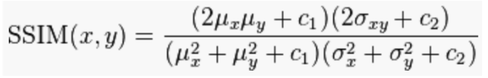

## References

[1] Zhou, W., A. C. Bovik, H. R. Sheikh, and E. P. Simoncelli. "Image Qualifty Assessment: From Error Visibility to Structural Similarity." IEEE Transactions on Image Processing. Vol. 13, Issue 4, April 2004, pp. 600–612.

**MSE:**

The PSNR block computes the peak signal-to-noise ratio, in decibels, between two images. This ratio is used as a quality measurement between the original and a compressed image. The higher the PSNR, the better the quality of the compressed, or reconstructed image.

The mean-square error (MSE) and the peak signal-to-noise ratio (PSNR) are used to compare image compression quality. The MSE represents the cumulative squared error between the compressed and the original image, whereas PSNR represents a measure of the peak error. The lower the value of MSE, the lower the error.

To compute the PSNR, the block first calculates the mean-squared error using the following equation:

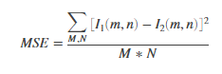

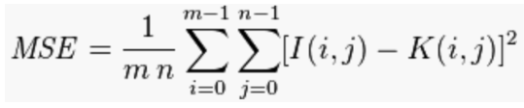

In the previous equation, M and N are the number of rows and columns in the input images. Then the block computes the PSNR using the following equation:



In the previous equation, R is the maximum fluctuation in the input image data type. For example, if the input image has a double-precision floating-point data type, then R is 1. If it has an 8-bit unsigned integer data type, R is 255, etc.